Community Walk
Followed by Lunch
Saturday 20th June

Meet at church 10.30am


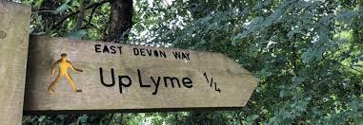
Or come for lunch at 12.00
Next walk Saturday 19th September
(no walk July or August)
For more information :
Contact Sue Wells 07912 272102

